**MSIS 619: Systems Analysis and Design**

**Group 2 - UML Models**

**Class Diagrams:**

The class diagram has the following classes.

**Donor:** Attributes are Donor’s name and ID. The donation is received alert is generated on the App.

**Student:** Students need to log in to the App. Each student has a unique Student ID, and others attribute like student Name and Phone number.

**Staff:** The Staff have full access to the inventory. If the stock runs out they need to contact the Donors and the suppliers i.e. the farmers for the grocery. The staff will generate the monthly report based on the payment received from each student's purchase history. Staff is one of the important classes that will generate alerts, and contacts, stock up the items and prepare the report monthly for the university.

**Suppliers:** The suppliers are farmers who will supply fresh vegetables and fruits in the U-Access store for the student at a minimal cost. The attributes of the suppliers are supplier ID, supplier name (SupplierName) and the City (SupCity) they are from.

**Inventory:** This will have all the product details available in U-Access. The different attributes like productid, ProductName, and AvailableQty. This will help the staff to have a record of the available items.

**Cart:** This will have attributes like cartID, The number of products available (Quantity), Product identification number (ProductID), and price of each product (Productprice).

**Payment:** The payment received from the student after they purchase a product from the store. It will have the attributes like payment received by a student in a given timestamp. This will also take student card details for the payment.

**Report:** Staff will create a monthly report based on the store's purchases. Which will help the staff to keep track of the profit and loss the new system is generating.

**Activity Diagram:**

**Actors**: Supplier, Staff, U-Access System and Student.

The Activity diagram starts with the Student placing an Online Order, adding items to Cart and making the payment for the items purchased.

**Goal**: Online Order placed and confirmed.

Below, The start state is the System which has all the payment details regarding the item purchased by the student in the store. The staff then access this data and generate a financial report and sends it to the University.

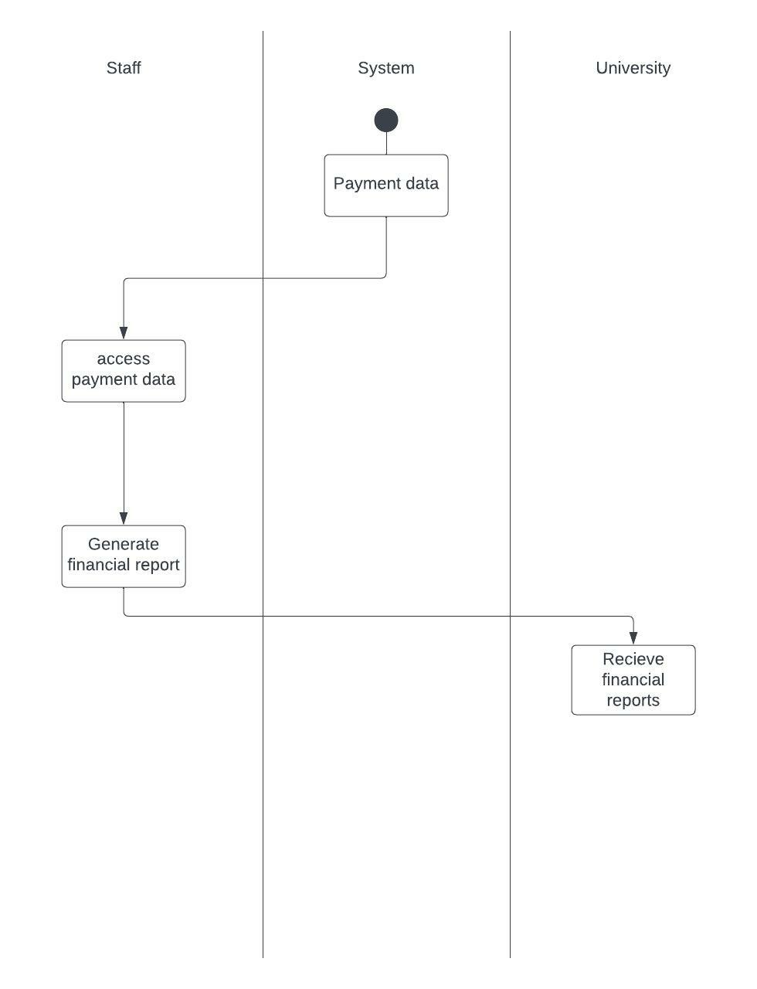

**Sequence Diagram:** Create sequence diagrams for two core business processes related to the functional problems you identified in the previous assignments. You can use the processes identified for the activity diagram to model sequence diagrams. For each sequence diagram

**Object:** Students, Login Windows, Grocery Items, New Registration, Cart, and Payment.

The Sequence starts with the actor student with an open() state. If the student is a registered student then he/she is able to view the grocery Items and add them to the cart. If the student is a new student then the student has to first register i.e. New Registration: Registration to the System to get all the privileges. After the items are added to the cart an Invoice is generated for the Payment once the order is confirmed by the students.

**Goals:** Order Placement for the food Item in the U-Access Store.

2) The staff will generate a monthly report which is sent to the university based on the profits earned by the U-Access store.

The Staff members would access the object payment to get all the payment records. The staff would get the generated report from the object report then the monthly report is sent to the university.

**State chart Diagram:**

Create state charts (transition diagrams) for at least three primary object classes. Base your models on the diagrams already discussed in class and general discussions in class.

1. The below State chart is for the login of the student to the system. Students will log in to the system if he/ she is valid students with the correct credential they can browse the items. If a student is new to the system they have to register first, a valid UMASS student can access the application. And, if the credentials are incorrect the message gets popped up “Wrong Password” and they have to re-login to the system with Valid creds.

1. The students will search for the items from the donation as well as the store as per their requirements. They will add those items to the cart and after the items are added to the cart the students have the option to add more items to the cart or else checkout.

1. This State chart diagram is for the process of the Payment. After the cart is checkout the student enters the card details those details are verified by the system. If the credentials are invalid the students are asked to enter the details again or else the credentials are verified and the user is authorised and the order is confirmed.

